
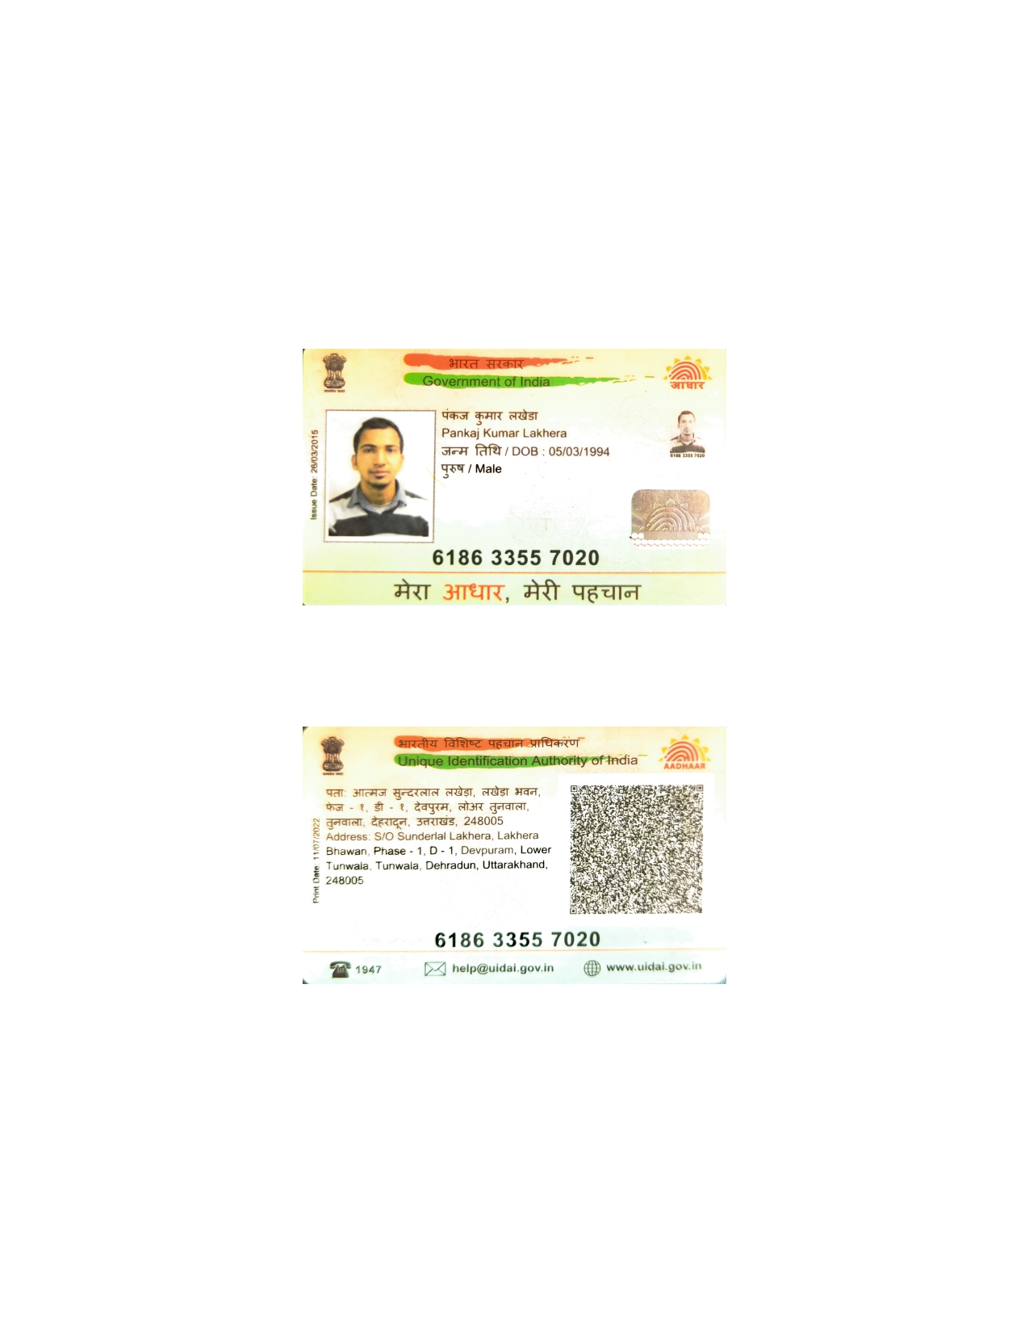

Video Link: Pankaj Lakhera _ Interview _ Dot Net Developer-20230905_120602-Meeting Recording.mp4

www.linkedin.com/in/pankaj-lakhera-321043aa
Pankaj Lakhera
Email id: pankajlakhera54@gmail.com
Contact No.: +91 8439503074

Full Stack .NET Developer

Professional Profile
- 7+ years of experience as Full stack .NET developer in software design, analysis, development, testing and implementation of web and client-server applications.
- Strong C# programming skills and object-oriented design.
- Expertise in .NET technologies as ASP.NET Web forms, MVC, Web API.
- Experience in client-side languages like JavaScript and TypeScript.
- Strong experience in client-side scripting frameworks like Vue.JS, jQuery, JavaScript.
- Experience in writing SQL queries, Stored Procedures, functions along with performance tuning.
- Proficient in writing Unit test cases using xUnit/ Jest and Cypress in UI following TDD & BDD approach.
- Experience in developing .NET Core Web API with microservice architecture.
- Experience in usage of API Tools (Swagger and Postman).
- Working experience in React and basic understanding of Redux/Flux.
- Worked on MSBI technologies like SSRS.
- Ability to learn & develop using new technologies quickly.
- Experience in Agile methodology and DevOps pipeline creation followed during development phase.

Academic Qualification
- B.Tech from Uttarakhand Technical University, Dehradun in 2015 with 71%
- 12th from Kendriya Vidyalaya, Srinagar Garhwal in 2011 with 81%
- 10th from Kendriya Vidyalaya, Srinagar Garhwal in 2009 with 81%

Experience
- Currently working at Halma India Pvt Ltd. Since Dec 2020
- Worked at Lowe’s Services India (Client Side) on Payroll of Tech Mahindra Ltd from Aug 2019 to Dec 2020
- Worked at FICO India from Oct 2018 to July 2019
- Worked at Grasko Solutions from Dec 2015 to Oct 2018

Technical Skills
- Server-side technologies: ASP.NET Web forms, ASP.NET MVC, Web API
- Client-side frameworks: jQuery, Vue.js, React.js
- Programming languages: C#, VB.NET, JavaScript, TypeScript
- Databases: MS SQL Server, Mongo DB
- MSBI: SSRS, Crystal Reports
- Version Control Tool: TFS, VSS, SVN, Bitbucket.
- Domain Knowledge: Home HealthCare/IVR/Retail/Safety
- Development Methodology: Agile, Scrum.

Projects
- FireMate Web (Dec 2020 till now)
  - Role: Senior Software Developer
  - Technologies used: ASP.NET Core, Web API, C#, SQL Server, Vue.JS, JavaScript, xUnit, Jest,MVC Architecture.
  - Description: This Application mainly focuses on fire protection and maintenance.
Tool build for Technician staff can login and see the various Customer/Contract/ Properties where Routine Activity and Job is created for a particular date and time assigned to them. On checking they may create a Service Request and quote accordingly.

  - Roles & Involvement: Designed and developed various screens from Scratch for the FireMate web application using Vue.JS
Involved in creating Backend API’s and Stored Procedures for the application built.
Involved in Code Reviews and Knowledge transition to new Employees joining team.

- reCap (Aug 2019 to Dec 2020)
  - Role: Software Developer
  - Client: Lowe’s India, Bangalore
  - Technologies used: ASP.NET Core Web API, C#, SQL Server, Vue.js, TypeScript, xUnit, Jest, Microservice architecture.
  - Description: This tool simplifies the work of supply chain engineers and supply chain planners by making the CAP process automated. Planners submit the items for required distribution centres and engineers approve/reject them. Planners must work on rejected items and re-submit until it is approved. Once the items are approved, they are slotted automatically by slotting API according to their dimensions.
  - Roles & Involvement: Designed and developed various modules of SCP Tool UI using Vue.js & React
Involved in building various micro services required for Supply chain engineer slotting.
Participated in hackathon for getting feasible UI design for SCP (Supply chain Planning) Tool.
Involved in unit testing/BDD the code using Xunit, SpecFlow & Jest.

- CCS (Oct 2018 to July 2019)
  - Role: Software Developer
  - Technologies used: C#, SQL Server, ASP.NET MVC, JavaScript
  - Description: CCS stands for Customer Communication Services. The Project provides Services like email, SMS and calls to end user if any fraud related transaction happened to their credit/Debit Card.
If Someone took loan amount from Bank and not paying Loan amount back to the Bank that time also our system will trigger SMS, calls and Email to the user till the time one is not giving money back.
- Roles & Involvement: Handling the change requests from client and developing them. Coding, resolving technical and design issues, unit testing. Able to use system and functional understanding of the project and technical expertise to quickly resolve productions issues.

- Kantime – Private Duty (Dec 2015 to Oct 2018)
  - Role: Software Developer
  - Technologies used: ASP.NET Web Forms, ASP.NET MVC, C#, SQL Server, jQuery, JavaScript, ADO.NET
  - Description: KanTime is a web-based software solution that enhances the operational efficiencies, thereby improving productivity of Skilled Care Providers. It helps to manage Client profiles, Caregiver/employee profiles, Plan of Care (Form CMS 1500), Scheduling, Timesheets and Payroll. Eliminates paper Timesheets with integrated Telephone based Check in and Check out and UB04.
- Roles & Involvement: Develop application involving the handling of different type of transactions or Change Requests from the client in Page Level.
Involved in research and development works, Database design and writing SQL queries.
Deploying Live issues/Cases coming those should deliver quickly/End of the day.

Hobbies & Interest
- Trekking, Playing Badminton & Cricket.

Personal Details
- Date of Birth: 05th Mar 1994
- Permanent Address: Lakhera Bhawan, Phase 1, D-1, Lower Tunwala, Devpuram, Dehradun.
- Marital Status: Single
- Nationality: Indian
- Languages Known: English, Hindi

Declaration
I hereby declare that the above-mentioned information is true to the best of my knowledge.

Date:
Place:
(PANKAJ LAKHERA)

